Creating class and its object

Workshop #1

Flutter Developer Bootcamp

# **Purpose**

This workshop demonstrates the basics of object-oriented programming (OOP) in Dart, specifically focusing on class creation, object instantiation, and accessing class fields.

**Problem**

In the given workshop demonstrates illustrates a simple scenario involving object-oriented programming. The main function, which serves as the entry point of the application, creates an instance of the cs class and prints the value of its field a. The cs class defines a field a initialized with the string 'This is variable a and is a field' and includes an empty constructor. When the object obj is instantiated using var obj = cs();, the constructor is called, though it performs no actions. The program then accesses and prints the value of a from obj, resulting in the output: This is variable a and is a field. This code demonstrates the basics of class instantiation, field initialization, and field access in Dart.You need to declare a variable ‘b’ and print a message ‘This is variable b from the constructor’

**How to Solve**

1. Checkout the workshop from Git Repo:

git clone -b <user-branch> <repo-URL>

1. Open the root folder inside VS Code
2. Open the root folder in terminal
3. Run the command dart run filename.dart
4. Declare the Variable b:

* Add a field b to the class cs.
* Initialize b with a default value.

1. Modify the Constructor:

* In the constructor of the class cs, print the message "This is variable b from the constructor".

1. Print the Value of b:

* Access and print the value of b from the main function.

1. Go To File: <specific-file--method> à <method-name>, implement your logic.

**You will Achieve**

When you complete this workshop you will learn the following:

**Methods and Functions Used:**

* **Class Field Declaration and Initialization:**
* Declaring a field a and initializing it with 'This is variable a and is a field'.
* Declaring a new field b and initializing it with 'Initial value of b'.
* **Constructor:**
* Modifying the constructor to include a print statement.
* **Main Function:**
* Creating an instance of the class cs.
* Printing the values of the fields a and b.

# **Screenshots**

## **Before implementation (without declaring variable b)**

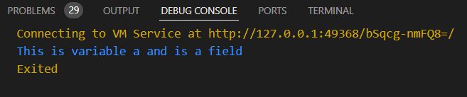

## **After implementation (with declaring variable b)**

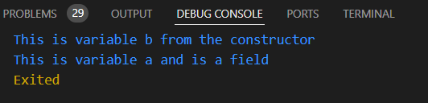

# **How to submit your workshop**

Push your project back to the same git branch using command:

<command name>

# **Happy Coding!**